# CS 499 Module One Assignment

1. **Self-Introduction:** Address all of the following questions to introduce yourself.
   1. How long have you been in the Computer Science program?

My first term at SNHU was the 22EW5 term, which I believe was around May 2022. Therefore, I have been a CS student for a little over two years now. This being my last term as a student at SNHU, I am looking forward to what the future holds in terms of my career and professional development.

* 1. What have you learned while in the program? List three of the most important concepts or skills you have learned.

Through my CS program studies, I have learned a lot. Some programming languages include Python, C++, Java, Javascript, and others. I used MongoDB and Postgres databases. Also, I learned about IT and cybersecurity, as well as project planning, through flowcharts and pseudo code. So those would be the most important concepts: programming languages, databases, and system security and planning.

* 1. Discuss the specific skills you aim to demonstrate through your enhancements to reach each of the course outcomes.

As far as I understand, in this class, we will need to enhance our artifact(s) in three key areas: Software Engineering and Design, Algorithms and Data Structures, and Databases. So, I plan to research and learn how to improve the artifact I have chosen to improve by demonstrating and documenting the entire process. Skills I aim to demonstrate are self-learning, attention to detail, clean code, dedication, self-improvement, and willpower to overcome difficult situations.

* 1. How do the specific skills you will demonstrate align with your career plans related to your degree?

After finishing this term, I hope to enter the industry through an entry-level position and receive my bachelor's degree. All the skills I mentioned in part C would be key areas employers would find valuable for a potential new hire.

* 1. How does this contribute to the specialization you are targeting for your career?

I do not know the exact specialization I am targeting for my career, as I have no professional experience in the tech field yet. My personal interests are development and mobile devices. However, I might look into IT/Cybersecurity since I recently connected with people in those fields. However, the skills mentioned before will be crucial and very beneficial for any specialization I end up with.

1. **ePortfolio Set Up:**
   1. Submit a **screen capture** of your ePortfolio GitHub Pages home page that clearly shows your URL.
      1. You already have a repository in GitHub where you uploaded projects in previous courses. Your ePortfolio will reside in GitHub but can link to work at other sites, such as Bitbucket.
   2. Use the GitHub Pages link in the Resource section for directions on:
      1. How to create your GitHub website and publish code to GitHub Pages
      2. Issues, such as adding links to other sites
   3. Paste a screenshot of your GitHub Pages home page with your URL clearly showing in the space below.

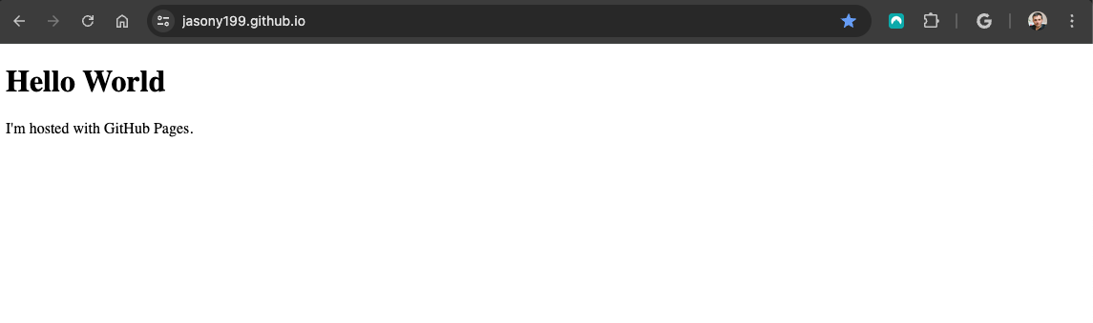

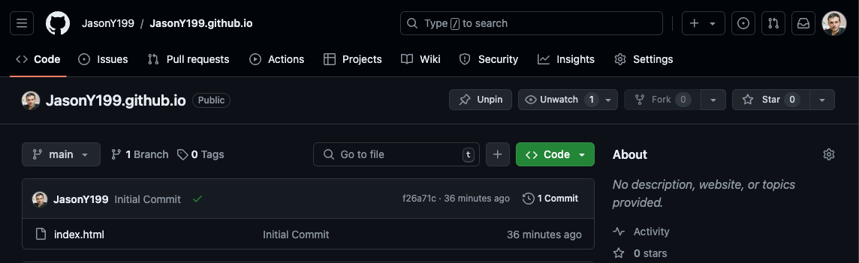

1. **Enhancement Plan:** 
   1. **Category One:** Software Engineering and Design  
      1. **Select an** **artifact** that is **aligned with** **the** software engineering and design **category** and explain its origin. Submit a file containing the code for the artifact you choose with your enhancement plan.

The artifact that I have chosen for this enhancement is Global Traveller, my personal travel and living blog, which I created for web design and development practice. The code file is attached to the submission.

* + 1. **Describe** a practical, well-illustrated **plan** for enhancement in alignment with the category, including a pseudocode or flowchart that illustrates the planned enhancement.   
         
       Initial Setup – Enhancement 1 Pseudocode  
       -NextJS framework with TypeScript and Tailwind CSS  
       -In the (components) folder:  
        -Header.tsx  
        -Footer.tsx  
        -About.tsx  
        -Hero.tsx  
        -Highlights.tsx  
        -Searchbar.tsx  
        -Destinations.tsx  
       -Folder with url slug for each page  
        -About-Me  
        -Page.tsx  
        -<<Component>> Header.tsx  
        -<<Component>> About.tsx  
        -<<Component>> Footer.tsx  
        -Destinations  
        -Page.tsx  
        -<<Component>> Header.tsx  
        -<<Component>> SearchBar.tsx  
        -<<Component>> Destinations.tsx  
        -<<Component>> Footer.tsx  
       -Layout.tsx (homepage)  
        -Header.tsx  
        -Hero.tsx  
        -Highlights.tsx  
        -Footer.tsx

I plan on making Software Engineering and Design enhancements to Global Traveler by re-creating the front end using React.js or a similar framework. I've always wanted to start a travel blog, but I haven’t had the courage to create one I would be proud to show the world. I see this project and enhancement as an opportunity to create a final product that I would be happy to showcase.

The current version of my website is built using basic HTML, CSS, and JavaScript. This means that if I need to update my site, I would have to take it offline, make changes (thus disrupting its traffic), and then try to put it back online again. I would also have to update every instance of every component. With Tailwind and React, since they are component-based, I only need to make changes to the main component file, and they will be applied globally.

By making these enhancements, Global Traveler will not only be more maintainable and scalable but also provide a better user experience, making it a site I would be proud to showcase to the world.

* + 1. Explain how the planned enhancement will **demonstrate** specific **skills** and align with course outcomes.
       1. Identify and describe the specific skills you will demonstrate that align with the course outcome.

For this enhancement, I will show through choosing a more modern and advanced framework for front-end development that I can use well-founded and innovative techniques, skills and tools in computing practices. I will also comment my code using industry best-practices so that I can build a collaborative environment - anyone that needs to pick up where I left off can do so with ease. This will also coincide with the course outcome to design, develop and deliver professional-quality oral, written and visual communications that are coherent, technically-sound and appropriately adapted to specific audiences and contexts.

* + - 1. Select one or more of the course outcomes below that your enhancement will align with.

**Course Outcome 1:** Employ strategies for building collaborative environments that enable diverse audiences to support organizational decision making in the field of computer science. **Course Outcome 2:** Design, develop, and deliver professional-quality oral, written, and visual communications that are coherent, technically sound, and appropriately adapted to specific audiences and contexts.

**Course Outcome 4:** Demonstrate an ability to use well-founded and innovative techniques, skills, and tools in computing practices for the purpose of implementing computer solutions that deliver value and accomplish industry-specific goals.

* 1. **Category Two:** Algorithms and Data Structures

1. **Select an artifact** that is **aligned with the** algorithms and data structures **category** and explain its origin. Submit a file containing the code for the artifact you choose with your enhancement plan. You may choose work from the courses listed under Category One.

For this enhancement, I’ve chosen to add to Global Traveller. The code for this included in my submissions. Global Traveller is my personal travel blog, which I intend to publish once all enhancements are completed, marking the beginning of my career as a travel blogger.

1. **Describe** a practical, well-illustrated **plan** for enhancement in alignment with the category, including a pseudocode or flowchart that illustrates the planned enhancement.

This enhancement ties in with Enhancement Three, where I add a MongoDB database to populate my data dynamically instead of hard-coding everything in. The destinations page of my blog showcases a list of destinations that I have been to, the best times to travel, local cuisine that I enjoy and a description of each one. When I begin writing my posts, they will each be tagged under the location. For this enhancement, I plan to create a more advanced filter that will allow my blog readers to search the destinations by continent, country, climate and best time of year to visit.  
  
Pseudocode – Enhancement 2  
1.Define route for GET /api/destinations with query parameters:  
 -Continent  
 -Country  
 -Climate  
 -bestTimeToVisit  
2.Extract query parameters into variables.  
3.Initialize an empty filter object.  
4.If continent/country/climate/bestTimeToVisit is provided:  
 -Add to filter object.  
5.Query database with filter object.  
6.Return results as JSON.

1. Explain how the planned enhancement will **demonstrate** specific **skills** and align with course outcomes.
   1. Identify and describe the specific skills you will demonstrate to align with the course outcome.

The specific skills I will demonstrate include algorithmic design, in which I design logic to handle various filtering parameters. I will also construct efficient queries to the MongoDB database to retrieve relevant data based on user input. In addition, in system design, I create a flexible filter object that can accommodate multiple optional parameters.

* 1. Select one or more of the course outcomes listed under Category One that your enhancement will align with.

**Course Outcome 3**: Design and evaluate computing solutions that solve a given problem using algorithmic principles and computer science practices and standards appropriate to its solution, while managing the trade-offs involved in design choices.

* 1. **Category Three: Databases**
     1. **Select an artifact** that is **aligned with the** databases **category** and explain its origin. Submit a file containing the code for the artifact you choose with your enhancement plan. You may choose work from the courses listed under Category One.

Enhancement Three will also be done on Global Traveller. The code for this has been uploaded as part of the submission. Global Traveller is a personal project that is intended to be a travel blog that I would like to deploy for public viewing.

* + 1. **Describe** a practical, well-illustrated **plan** for enhancement in alignment with the category, including a pseudocode or flowchart that illustrates the planned enhancement.

Pseudocode - Enhacement 3

1.Initialize MongoDB Client  
 -Connect to MongoDB server  
2.Create new database  
 -Assign name to database  
 -Create database if it does not yet exist  
3.Create Collection  
 -Assign name to collection

4.Insert documents (in this case the JSON file with the destinations and their data)  
 -Define documents as key-value pairs  
5.Query documents from the collection  
 -Define query criteria  
 -Fetch documents matching the query criteria  
 -Display or process the fetched documents  
6.Handle Exceptions  
 -Implement error handling for database operations

-Log or display error message as needed  
  
There are many different types of database and back-end technology that are available to use. However, I chose MongoDB specifically as it is document-oriented (a NoSQL database that stores data in flexible JSON-like documents). This is particularly useful for the travel blog as there are different fields (some may have more images or information than others). MongoDB also provides high performance for both read and write operations, which is important for later when I create the actual blog and new content is added and accessed. Initially locally hosted on MongoDB Compass, I will move my database to MongoDB Atlas so that I can have a key to insert into the route.  
  
My secrets (the API key) will be stored in an .env file, which will be placed into a .gitignore so that it can be securely placed online on GitHub and thereby hosted online safely.

* + 1. Explain how the planned enhancement will **demonstrate** specific **skills** and align with course outcomes.
       1. Identify and describe the specific skills you will demonstrate that align with the course outcome.

Ensuring the security of the MongoDB database authentication, encryption and access controls shows that I am taking a security-conscious approach. Furthermore, using MongoDB Atlas leverages its built-in security features so that my data can be protected. Thus the skills I will demonstrate with this enhancements is security awereness and implementation.

* + - 1. Select one or more of the course outcomes listed under Category One that your enhancement will align with.  
           
         **Course Outcome 5**: Develop a security mindset that anticipates adversarial exploits in software architecture and designs to expose potential vulnerabilities, mitigate design flaws, and ensure privacy and enhanced security of data and resources.

1. **ePortfolio Overall Skill Set**
   1. Accurately describe the **skill set** to be illustrated by the **ePortfolio** **overall**.  
      1. Skills and outcomes planned to be illustrated in the code review

First and foremost, I am planning to showcase my strong understanding of coding best practices as well as the intended enhancements and their potential impact on my full-stack website. I am to show Course Outcome Two, which is to design, develop, and deliver professional-quality oral, written, and visual communications that are coherent, technically sound, and appropriately adapted to specific audiences and contexts. This will be demonstrated through fluently narrating the code review, specifically going into “What Went Well” and “What I Could Do Better”.  
  
This in in addition to my knowledge and skill in full-stack development. Thus, my code review will prominently demonstrate:

**Course Outcome 2**: Design, develop, and deliver professional-quality oral, written, and visual communications that are coherent, technically sound, and appropriately adapted to specific audiences and contexts.

**Course Outcome 1**: Employ strategies for building collaborative environments that enable diverse audiences to support organizational decision making in the field of computer science

* + 1. Skills and outcomes planned to be illustrated in the narratives

Research and communication are critical skills in today’s workforce. From my review of the course syllabus, I am looking to leverage my research skills to (as in Course Outcome 2) design, develop, and deliver professional-quality oral, written, and visual communications that are coherent, technically sound, and appropriately adapted to specific audiences and contexts. Additionally, I will also demonstrate my ability to design and evaluate computing solutions that solve a given problem using algorithmic principles and computer science practices and standards appropriate to its solution, while managing the trade-offs involved in design choices (as in Course Outcome 3).

* + 1. Skills and outcomes planned to be illustrated in the professional self-assessment

My professional self-assessment will showcase me as a professional, therefore most prominently Outcome One (employing strategies to build collaborative environments), Outcome Two, (to design and develop professional-quality oral, written and visual communications), Three (my problem-solving skills) and also Outcome Four (using well-founded techniques and skills). Ultimately, the goal is to demonstrate my readiness for the workforce, build a portfolio that represents me well as a software engineer and to prepare for any academic or professional pursuits that are to come my way.